Making Groovy Digital Images
with Tanya Ellenburg-Kimmet, Wright State University

Want to know some basic tips to make your photos groovy? Like… Did cosmic vibration make the image blurry or out of focus while the camera is still? Why did resizing make it look psychedelic? What’s the hype with TIF, JPG, or GIF? Come to rap in class about earth friendly photography; learn to make smashing photo art. Bring your camera (optional/not needed) and your questions. Come get in the groove with a shutterbug while we work on our digital image karma.

So You Want to make a Photo:

Camera Basics:
Exposure is the amount of light reaching the sensor (film), leading to this algorithm: E=I x T
Exposure =Intensity (aperture) x Time (shutter)

Exposure is controlled by 4 Factors:
- Aperture Scale (F-stop): Lens opening; the higher the number, the smaller the opening
- Light: amount of light at the scene
- Shutter Speed Scale: length of exposure; numbers are fractions of a second
- ISO Scale (sensitivity to light): the higher the ISO the more light sensitive (and the more “grain”)
Meter sees 18% gray

Aperture Scale
1, 1.4, 2, 2.8, 4, 5.6, 8, 11, 16, 22, 32, 45, 64, 90___
More exposure Less exposure

Shutter Speed Scale
30”, 15”, 8”, 4”, 2”, 1”, 1/2, 1/4, 1/8, 1/15, 1/30, 1/60, 1/125, 1/250, 1/500, 1/1000, 1/2000, 1/4000, 1/8000
More Exposure Less Exposure

*Anything to the left of 1/60 or F-60 is going to require a camera stand or your hand movements will blur the image. But there’s a trick around this too.
Sunny f/16 rule states that on a sunny day the exposure is f/16 @ 1/ISO
If using ISO 100, the exposure is f/16 @ 1/125
If using ISO 400 the exposure is f/16 @ 1/500
(most digital cameras have a meter guideline internally)

To take a picture:
- Set the ISO
- Evaluate the light with a meter (or guestimate)
- Set the Aperture
- Set the Shutter Speed

Some quick terms:
- Bracketing: purposely over or under exposing to get an effect. This is also handy if the scene is irregular (lots of white or lots of dark), because the meter will compensate and mess up your image. Therefore, you can fool it by increasing or decreasing the F-stop (without messing with the shutter speed) for a shot or two for choices later. Note: backlighting will fool the camera…
- Frame: the lens naturally creates a circular image; the camera makes it rectangular
- Scale: size of the subject
- Composition: including the three elements - subject, form, and content
- Elements of Design: aspects in the photo like Line, Shape, Value/Form, Color, Texture, Pattern, Balance, Plane, Rule of Thirds, Triangular Compositions, Curvilinear Compositions, Circular Compositions, and Diagonal Compositions.
- Focusing: 1/3 distance in front of the subject; 2/3 distance behind the subject. The size of distance is the depth of field (sharpness of the image). IF you increase F-stop, you must decrease shutter speed (exposure) and vice versa unless you are bracketing. Shallow depth of field is when little else than the subject is in focus; great depth of field is when the scene is sharp front to back
- Depth of field is controlled by:
- Aperture: Less DoF- 1.4, 2, 2.8, 4, 5.6, 8, 11, 16, 22 more DoF
- Scale of the subject due to distance to the camera, focal length of the lens
- Motion:
  - To stop or blur
    - To freeze action: short exposure - 1/250-1/2000 is recommended depending on the item moving (children being 1/250 – sporting events and birds being 1/1000)
    - To capture motion: long exposure – ½ to 10 seconds depending on the item moving (fireworks being ½- cars being 10 seconds)
  - Speed of Subject: The faster the subject, the faster the shutter speed needed
  - Direction of Motion (perpendicular to the lens, facing it’s movement to or fro) or track the item as it moves and have a blurred background (aka Creative Control Panning)
  - Size of the Subject: distance and focal length change

Now… all of this takes us to digitization of analog images; techniques used after the scanning segment also help in the cleaning up of photos from the digital camera.

So You Want to Digitize a Photo:

Rules for scanning and editing images.
- Scan image and name that image as a master scan.
- For every change in the image, save image NOT as a master scan. You can resave over another non-master scan, but saving over master scans can bring great regrets later.
- Scan master scans at 300+ (600 if possible). Make sure it’s not interpolated.
Image types:
Lossy (compressed): JPG, GIF
Lossless (uncompressed): RAW, BMP, PNG, XCF, PSD, NEF, ORF

How to set up GIMP:
http://www.gimp.org/downloads/
- Click on download GIMP
- When the window pops up, select save file. A second window may pop up asking where to save it – probably to a downloads folder or desktop, write down where it says and select save. This takes a few minutes.
- Go to location where you’ve saved the file (downloads folder or desktop). Double click to install. Select Run. It’ll ask for language – select your choice. It’ll ask to customize, install, or cancel. Select Install.
- It’ll then tell you it’s finished installing. Select Finish.
- OPTIONAL: Find GIMP in the start menu and right click on it if you’d like to save an icon shortcut to the desktop for ease of use.

How to scan: varies from scanner to scanner, but is roughly the same
- Put image on scanner, pre-scan
- Set dpi and size of scan if necessary
- Hit scan

How to Use GIMP:
Select File Open. Find photograph previously scanned. Save under a new name so as not to ruin your master scan. Work in layers if possible so your original is on the bottom layer and a copy is on top that you are altering… You won’t see the original, but you also won’t have to delete the entire file to start over. If in doubt on how to do something… google the effect you want and the program you’re using (smoky effect in GIMP, sunburst effect in Photoshop, etc.)
means looks like
means use sparingly, too much can distort/deform the picture
means this is an artistic affect and will most likely remove realism from your photo

Some tools
- Rectangle Select (looks like a dotted box): Use to select a rectangular part of your image
- Ellipse Select (looks like a dotted oval): Use to select an oval part of your image
- Free Select (looks like a dotted box): Use to select a hand drawn part of your image
- Fuzzy Select (looks like a dotted box): Use to select a color ranged part of your image
- Color Picker tool (eyedropper): lets you select color for painting, drawing or fill
- Zoom tool (magnifying glass): lets you zoom in or out on the photo
- Rotate tool (a box with arrows at opposite corners): lets you rotate the image
- Scale (a small box with an arrow going to a big box): lets you resize image in proportions
- Flip tool (folded paper with a double-ended arrow): lets you flip horizontally or vertically
- Text tool (a Capital A): lets you add a layer of text to your image
- Healing tool (crossed Band-Aids): eases out irregularities such as dust, hair, etc.
- Blur tool (a water drop): Eases off details, blurring them
- Smudge tool (a pointing finger): Blends details, smudging them
- Burn tool (a black rounded tool on a stick): Burns in details, hardening them

Some menu items
- File Save: Saves as a xcf (GIMP standard format)
- File Export: Saves as any format you choose, including tif and jpg
- File Print: Prints it
- Edit Undo: Allows you to undo the last edit, can be repeated
- Edit Cut, Copy, and Paste work sort of like MS Word functions using the Select tools mentioned above
- View Zoom: Allows you to zoom by percentage
- Image Crop to Selection: if used after selecting with a selection tool, crops out everything outside of the selection barrier
- Image Flatten Image: allows you to compress the layers you just built so the file can be saved or printed For best results, do this as a last step before saving or printing
- Colors Balance: change shadows, midtones, and highlights in color shifts, aka make your reds less red, your shadows less red
- Colors Hue-Saturation: removes color from the image, if it looks like Oz
- Colors Colorize: another way to lessen or brighten the color or remove the color
- Colors Brightness – Contrast: increase or decrease the brightness or the contrast
- Colors Threshold: effects the threshold of the image – reducing to two colors
- Colors Levels: alter the edges of white space, dark space, and midtones
- Colors Curves: alters the curve of the image
- Colors Posterize: removes the “realness” of the image
- Colors Desaturate: auto removes color on lightness, luminosity, or average basis to make images greyscale or black and white
- Filters Blur: gives different forms of blur – if your image is pixilated or looks like it was made on a dot printer, you can use Gaussian blur especially to fix it
- Filters: All other filters cause artistic qualities like making the image a watercolor painting and such
- Help: Yes… it even has a help feature! It may point you to the manual online but that’s better than nothing

Anatomy of the Digital Image: height x width x resolution

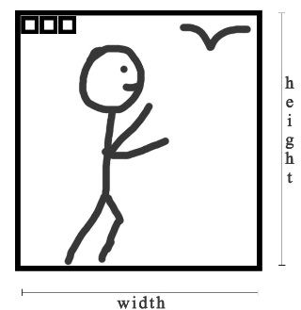
(drawing by Tanya Ellenburg-Kimmet)
Any given photo has a height and a width even in the analog world

In the digital world, there is one more attribute, resolution
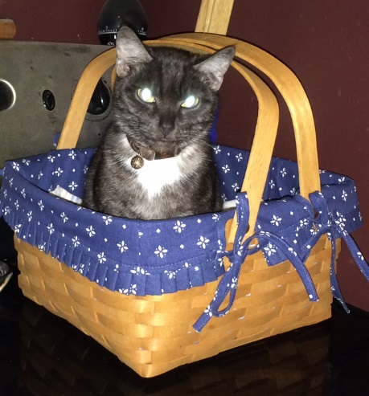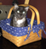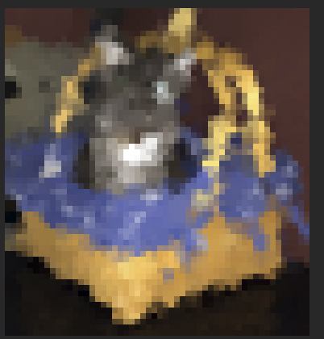
(images Tanya Ellenburg-Kimmet photography “Sekhmet”)

About Resizing and Cropping:

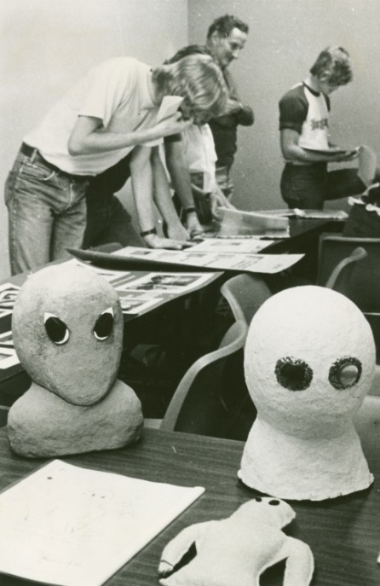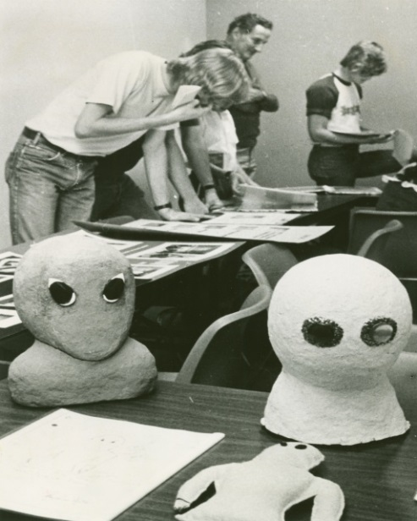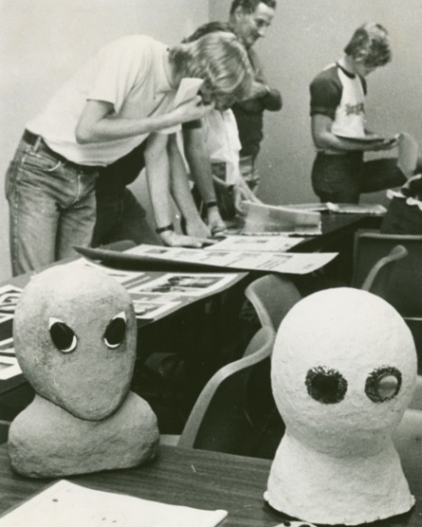
7 x 11 image make it 8x10 = distorted or crop it to 8x10 to preserve image
(images courtesy of Wright State University Archives)

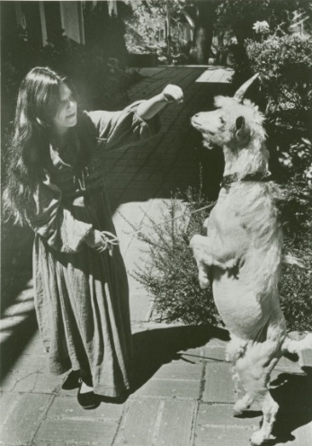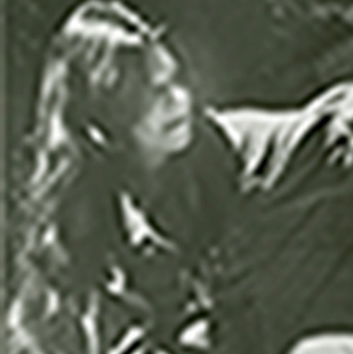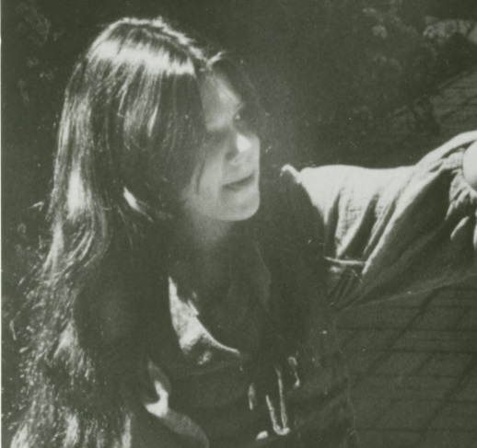
Original image cropped if the image was 72dpi cropped if the image was 300dpi
(images courtesy of Wright State University Archives)

1 x 1.5 x 72 dpi image on internet when resized to 30x30 looks bad. Need find a higher resolution… the monitor and printer will try to fix it, but they are not miracle workers.
Reducing dpi and dimensions makes the file size smaller and looks fine on the internet/emails. For the long term and for projects, like physical print outs, reduced file sizes are frustrating and may make the image useless.

Help! I’ve forgotten everything that the Library Scanning Lady said, what do I do?

Photography
https://expertphotography.com/understand-iso-4-simple-steps/
https://www.digitaltrends.com/photography/what-is-iso-camera-settings-explained/
https://photographylife.com/what-is-iso-in-photography

Gimp
http://www.gimp.org/tutorials/
http://www.youtube.com/watch?v=kB2dQcpTZHE
http://www.youtube.com/watch?v=8LmW5ndnEqw
http://www.gimpology.com/

And if you know Photoshop, one can make GIMP work like it http://www.smashingmagazine.com/2009/04/03/8-handy-tweaks-to-make-gimp-replace-photoshop/

And last but not least: email Tanya ~ tanya.kimmet@wright.edu
https://www.libraries.wright.edu/community/knowledgexchange/2014/09/03/digitization-blues-scanning-negatives/
http://cyberwildstar.weebly.com/digital-cyberwildstar.html

