Digitization Blues – Scanning Negatives

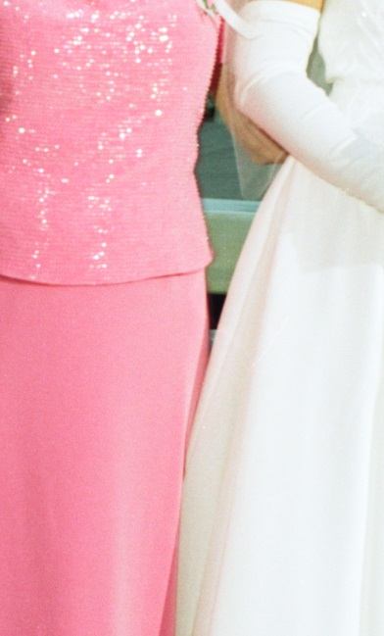
Photographers are artists and have ideas on how they want their art to look. When an image is printed by the photographer, whether via chemical processing or digital photo editing and a printer, it is ideally created with the photographer’s artistic choices. Thus, scanning this photograph is merely choosing to make it look like the original (“merely” is a bad word choice because it’s not that easy, but it’s easier than the area in which I’m about to delve).
Figure 1 Pink v. White Glow War – adjust mid-tone and exposure. Desaturate if necessary.

Scanning Negatives is a whole different circus. The digitizer has highlights and shadows to set and guide the process, but not the photographer’s eye to help show what the artist intended. Why did he or she light the area so? Why did he not plan for the white of the wedding dress to wash out the bride’s face? Why did she not see that the guest in the bright red would have a glow war with the white of the groom’s tux? For class photos in school, I was constantly reminded by my mother not to wear white or red because of how it discolors my face in the photo, so it’s not a foreign concept to some, but it is an issue that is easier dealt with before the negative is made, even if only by the photographer’s choices.

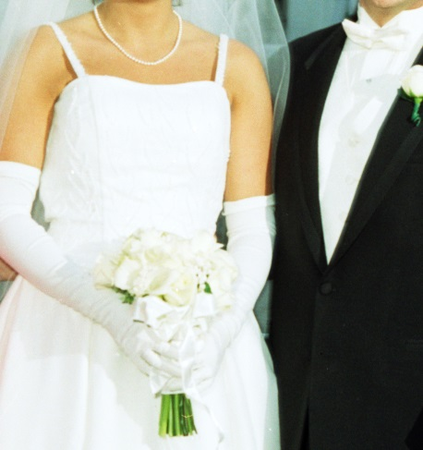
Those who digitize can only do triage, however. There are many different settings in the scanning software, Photoshop, and other photo editors where one can choosing type of film, highlights, shadows, saturation, contrast, and the like that help fix each issue, but it becomes an intricate balance of setting adjustment to make the image turn out. Just when the guest’s red dress doesn’t make her skin look burned and the groom’s tux no longer washes out his face, the digitizer sees that the bride’s dress has embroidered white on white. This is after fighting with lens flash flares, reflection glares, and Moiré patterns from the glossiness of the negative (the quick fix for the latter is to flip it over and reverse the image in the scanning program).
Figure 2 White on White –front lighting blends the white - use contrast and mid-tone adjustment to balance

It would be simple to give the photographer the shopping list of ideas on watching that mirror or window’s impact, using natural lighting, and telling people not to wear bright red, yellow, or white. However, most photographers know how to work with these elements and work around these elements. The digitizer can’t be choosy. So, it’s back to adjusting the highlights and shadows to keep the photo from washing out, easing the contrast up to bring back details, watching the saturation to keep the colors overcoming lighter colors, and checking your mid-tone range.

